**National University of Computer & Emerging Sciences, Karachi**

**Computer Science Department**https://lh6.googleusercontent.com/oU-pc0G73TyuxcnhgFaIKCu5BAtLGu4dvnZLj6jV7uQpnGMloG4MWWDdoIuQZPAev0xvaxy7A9cp5kVc8YPTjAFLsQNaGL81IM4-PQf4o9_cW4abCg90U4EVUwDMAfQdlNbTz8tR

**Lab Manual - 01**

|  |  |
| --- | --- |
| **Course Code: CL-217** | **Course : Object Oriented Programming Lab** |
| **Instructor(s)** | **Nida Munawar** |

# CONTENTS:

1. Predefined Functions
2. User-Defined Functions
3. Function Parameters.
   1. Value Parameters
   2. Reference Parameters
4. Scope of an Identifier.

# PREDEFINED FUNCTIONS

Functions in C++ are similar to that of in Algebra. For Example, every function has a name and depending on the value specified by the user. It does some computation and gives an output (if any).

Some examples for the built in functions are given below.

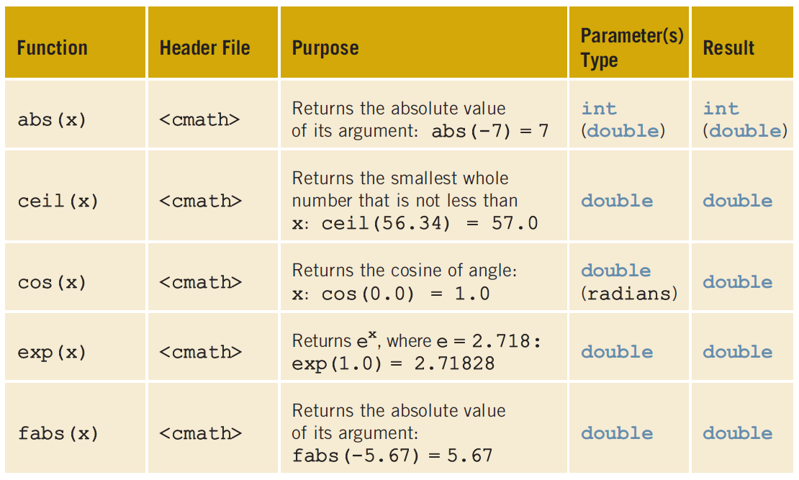

## Example Code for Predefined Functions:

//How to use predefined functions.

#include <iostream>

#include <cmath>

#include <cctype>

using namespace std;

int main ()

{

int x;

double u, v;

u = 4.2; //Line 1

v = 3.0; //Line 2

cout << "Line 3: " << u << " to the power of "

<< v << " = " << pow (u, v) << endl; //Line 3

cout << "Line 4: 5.0 to the power of 4 = "

<< pow (5.0, 4) << endl; //Line 4

u = u + pow (3.0, 3); //Line 5

cout << "Line 6: u = " << u << endl; //Line 6

x = -15; //Line 7

cout << "Line 8: Absolute value of " << x

<< " = " << abs(x) << endl; //Line 8

return 0;

}

Sample Run:

Line 3: 4.2 to the power of 3 = 74.088

Line 4: 5.0 to the power of 4 = 625

Line 6: u = 31.2

Line 8: Absolute value of -15 = 15

# USER DEFINED FUNCTIONS

User defined functions are classified into two categories.

* **Value-Returning Functions:** These functions return a value of a specific type using *return* statement.
* **Void Functions:** These functions *do not* use a *return* statement to return a value.

## VALUE-RETURNING FUNCTIONS:

Value-returning functions can be utilized in one of three ways:

* Save the value for further calculation.
* Use the value in some calculation.
* Print the value.

These function can be called in following scenarios.

* In an assignment statement.
* As a parameter in a function call.
* In an output statement.

Syntax:

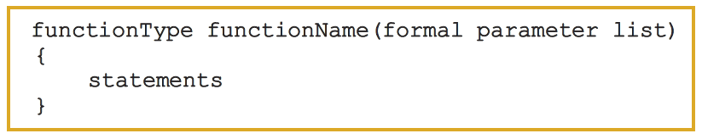

Example Code for Value Returning Functions:

double larger (double x, double y)

{

double max;

if (x >= y)

max = x;

else

max = y;

return max;

}

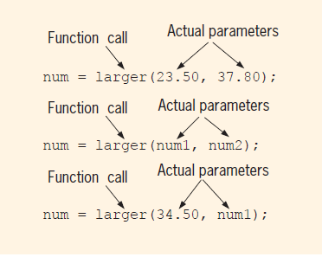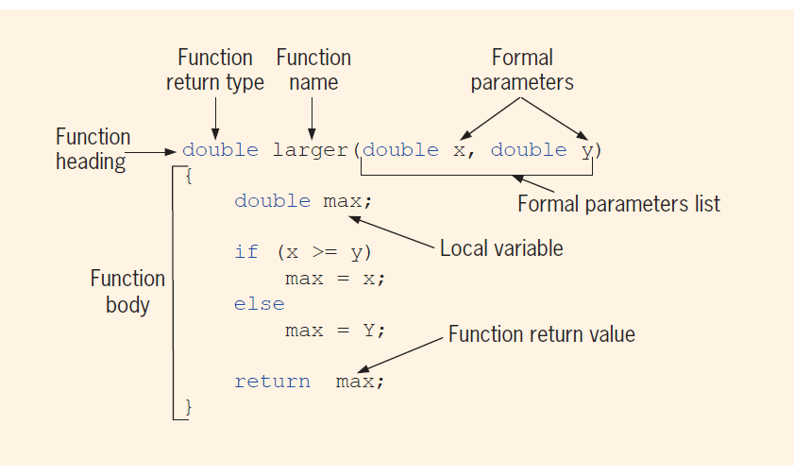Components:

Usage in cout:

cout << "The larger of 5 and 6 is " << larger (5, 6)

<< endl; //Line 1

cout << "The larger of " << one << " and " << two

<< " is " << larger (one, two) << endl; //Line 2

cout << "The larger of " << one << " and 29 is "

<< larger (one, 29) << endl; //Line 3

maxNum = larger (38.45, 56.78); //Line 4

Usage in another Function:

double compareThree (double x, double y, double z)

{

return larger (x, larger (y, z));

}

Some Peculiarities in Functions:

A function with a returning must return a value. Consider the following function.

int secret (int x)

{

if (x > 5) //Line 1

return 2 * x; //Line 2

}

Now in this function when the condition of *x > 5* is not met then the return statement will not execute. Hence resulting in no return value. In this case function may or may not return a meaningful value. It may result some strange value.

# FUNCTION PARAMETERS:

When passing parameters to a function there are ways to do that.

* + - 1. Value Parameters (Pass by Value).
      2. Reference Parameters (Pass by Reference).

## VALUE PARAMETERS:

When passing value parameters in a function, the parameter is copied into the corresponding formal parameter. There is no connection between the actual and formal parameter values, this means that these parameters cannot be used to pass the result back to the calling function.

Example Code for Value Parameters:

#include <iostream>

using namespace std;

void funcValueParam (int num);

int main ()

{

int number = 6; //Line 1

cout << "Line 2: Before calling the function "

<< "funcValueParam, number = " << number

<< endl; //Line 2

funcValueParam(number); //Line 3

cout << "Line 4: After calling the function "

<< "funcValueParam, number = " << number

<< endl; //Line 4

return 0;

}

void funcValueParam (int num)

{

cout << "Line 5: In the function funcValueParam, "

<< "before changing, num = " << num

<< endl; //Line 5

num = 15; //Line 6

Value Parameters | 367

cout << "Line 7: In the function funcValueParam, "

<< "after changing, num = " << num

<< endl; //Line 7

}

Sample Run:

Line 2: Before calling the function funcValueParam, number = 6

Line 5: In the function funcValueParam, before changing, num = 6

Line 7: In the function funcValueParam, after changing, num = 15

Line 4: After calling the function funcValueParam, number = 6

## REFERENCE PARAMTERES:

When a reference parameter is passed in a function, it receives the address (memory location) of the actual parameter. Reference parameters can change the value of the actual parameter.

Reference parameters are useful in following situations.

1. When the value of the actual parameter needs to be changed.
2. When you want to return more than one value from a function.
3. When passing the address would save memory space and time relative to copying a large amount of data.

Example code for Reference Parameters:

//This program reads a course score and prints the

//associated course grade.

#include <iostream>

using namespace std;

void getScore (int& score);

void printGrade (int score);

int main ()

{

int courseScore;

cout << "Line 1: Based on the course score, \n"

<< " this program computes the "

<< "course grade." << endl; //Line 1

getScore(courseScore); //Line 2

printGrade(courseScore); //Line 3

return 0;

}

void getScore (int& score)

{

cout << "Line 4: Enter course score: "; //Line 4

cin >> score; //Line 5

cout << endl << "Line 6: Course score is "

<< score << endl; //Line 6

}

void printGrade (int cScore)

{

cout << "Line 7: Your grade for the course is "; //Line 7

if (cScore >= 90) //Line 8

cout << "A." << endl;

else if (cScore >= 80)

cout << "B." << endl;

else if (cScore >= 70)

cout << "C." << endl;

else if (cScore >= 60)

cout << "D." << endl;

else

cout << "F." << endl;

}

Sample Run: In this sample run, the user input is shaded.

Line 1: Based on the course score, this program computes the course grade.

Line 4: Enter course score: 85

Line 6: Course score is 85

Line 7: Your grade for the course is B.

Example code for Value & Reference Parameters:

//Example 7-6: Reference and value parameters

#include <iostream>

using namespace std;

void funOne (int a, int& b, char v);

void funTwo (int& x, int y, char& w);

int main ()

{

int num1, num2;

char ch;

num1 = 10; //Line 1

num2 = 15; //Line 2

ch = 'A'; //Line 3

cout << "Line 4: Inside main: num1 = " << num1

<< ", num2 = " << num2 << ", and ch = "

<< ch << endl; //Line 4

funOne (num1, num2, ch); //Line 5

cout << "Line 6: After funOne: num1 = " << num1

<< ", num2 = " << num2 << ", and ch = "

<< ch << endl; //Line 6

funTwo (num2, 25, ch); //Line 7

cout << "Line 8: After funTwo: num1 = " << num1

<< ", num2 = " << num2 << ", and ch = "

<< ch << endl; //Line 8

return 0;

}

void funOne (int a, int& b, char v)

{

int one;

one = a; //Line 9

a++; //Line 10

b = b * 2; //Line 11

v = 'B'; //Line 12

cout << "Line 13: Inside funOne: a = " << a

<< ", b = " << b << ", v = " << v

<< ", and one = " << one << endl; //Line 13

}

void funTwo (int& x, int y, char& w)

{

x++; //Line 14

y = y * 2; //Line 15

w = 'G'; //Line 16

cout << "Line 17: Inside funTwo: x = " << x

<< ", y = " << y << ", and w = " << w

<< endl; //Line 17

}

Sample Run:

Line 4: Inside main: num1 = 10, num2 = 15, and ch = A

Line 13: Inside funOne: a = 11, b = 30, v = B, and one = 10

Line 6: After funOne: num1 = 10, num2 = 30, and ch = A

Line 17: Inside funTwo: x = 31, y = 50, and w = G

Line 8: After funTwo: num1 = 10, num2 = 31, and ch = G

## REPRESENTATION OF VARIABLES:

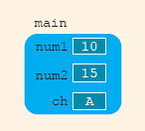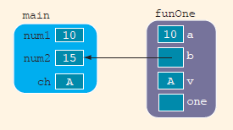After Line 3: Before Line 9: (In Function *funOne*)

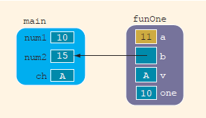After Line 9: After Line 10:

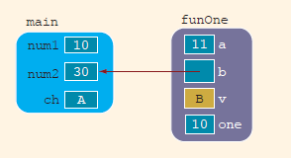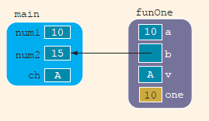After Line 11: After Line 12:

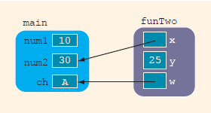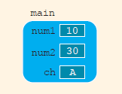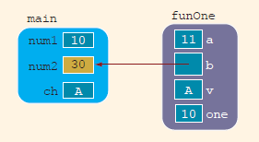On Line 6: (When the function ends) After Line 14: (In Function *funTwo*)

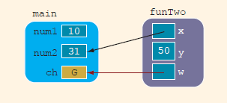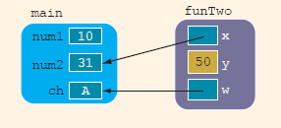After Line 15: After Line 16:

At Line 8 (When Function Ends):

# SCOPE OF AN IDENTIFIER:

When talking about scope of an identifier we define it in two terms:

**Local:** Identifiers that are declared within a function or a block.

**Global:** Identifiers that are declared outside every function definition.

In general, the following rules apply when an identifier is accessed:

1. Global identifiers (such as variables) are accessible by a function or a block if:

a. The identifier is declared before the function definition (block),

b. The function name is different from the identifier,

c. All parameters of the function have names different than the name

of the identifier, and

d. All local identifiers (such as local variables) have names different

than the name of the identifier.

2. (Nested Block) An identifier declared within a block is accessible:

a. Only within the block from the point at which it is declared until

the end of the block, and

b. By those blocks that are nested within that block if the nested block

does not have an identifier with the same name as that of the outside

block (the block that encloses the nested block).

3. The scope of a function name is similar to the scope of an identifier

declared outside any block. That is, the scope of a function name is the

same as the scope of a global variable.

Following program illustrates the rules of scope:

#include <iostream>

using namespace std;

const double RATE = 10.50;

int z;

double t;

void one (int x, char y);

void two (int a, int b, char x);

void three (int one, double y, int z);

int main () {

int num, first;

double x, y, z;

char name, last;

....

return 0;

}

void one (int x, char y) {....}

int w;

void two (int a, int b, char x)

{

int count;

....

}

void three (int one, double y, int z)

{

char ch;

int a;

....

//Block four

{

int x;

char a;

....

}//end Block four

....

}

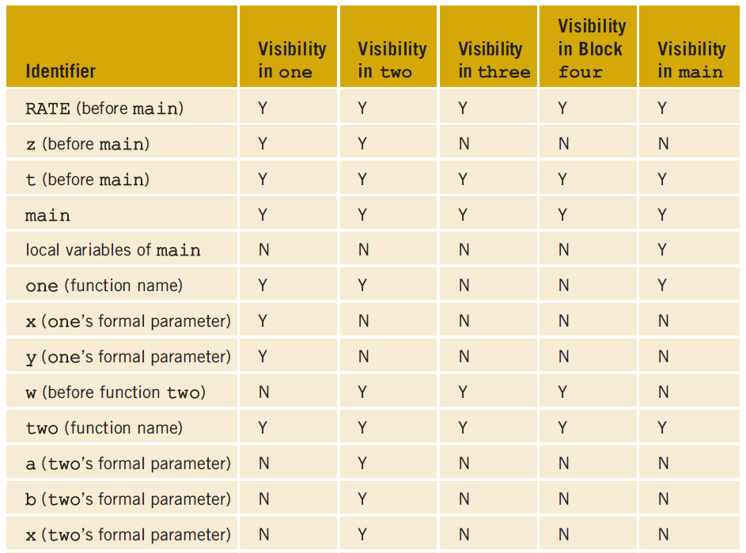 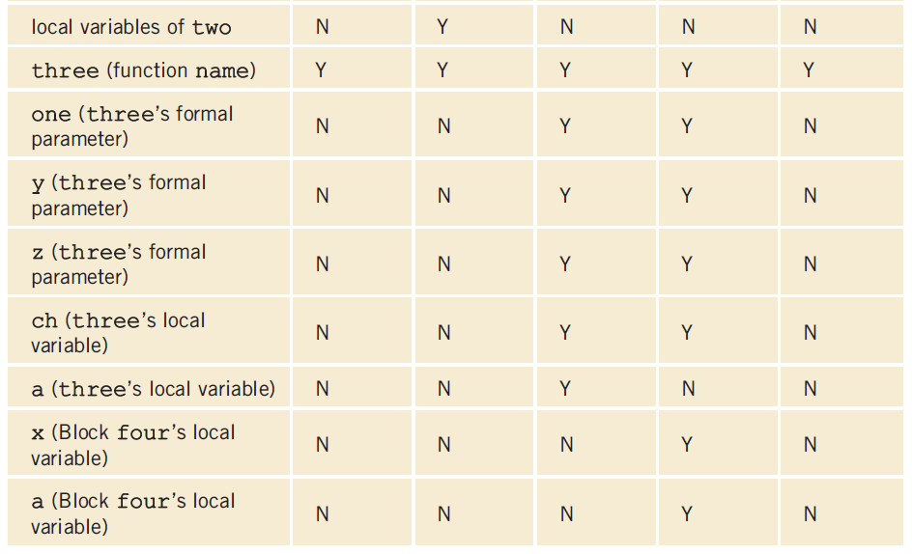

# STATIC & AUTOMATIC VARIABLES:

* A variable for which memory is allocated at block entry and deallocated at block exit is called an **automatic variable**.
* A variable for which memory remains allocated as long as the program executes is called a **static variable**.

Global variables are static variables by default and variables declared in a block are automatic variables. Syntax for declaring a static variable is:

## Example Code for Static Variables:

//Program: Static and automatic variables

#include <iostream>

using namespace std;

void test ();

int main ()

{

int count;

for (count = 1; count <= 5; count++)

test ();

return 0;

}

void test ()

{

static int x = 0;

int y = 10;

x = x + 2;

y = y + 1;

cout << "Inside test x = " << x << " and y = "

<< y << endl;

}

Sample Run:

Inside test x = 2 and y = 11

Inside test x = 4 and y = 11

Inside test x = 6 and y = 11

Inside test x = 8 and y = 11

Inside test x = 10 and y = 11

# LAB TASKS:

## TASK – 01:

This programming exercise demonstrates a program that calculates a customer’s bill for a local cable company. There are two types of customers: residential and business. There are two rates for calculating a cable bill: one for residential customers and one for business customers. For residential customers, the following rates apply:

* Bill processing fee: $4.50
* Basic service fee: $20.50
* Premium channels: $7.50 per channel.

For business customers, the following rates apply:

* Bill processing fee: $15.00
* Basic service fee: $75.00 for first 10 connections, $5.00 for each additional connection
* Premium channels: $50.00 per channel for any number of connections

The program should ask the user for an account number (an integer) and a customer

code. Assume that R or r stands for a residential customer, and B or b stands for a

business customer

**Input**: The customer’s account number, customer code, number of premium channels to which the user subscribes, and, in the case of business customers, number of basic service connections.

**Output**: Customer’s account number and the billing amount.

Because there are two types of customers, residential and business, the program contains two separate functions: one to calculate the bill for residential customers and one to calculate the bill for business customers. Both functions calculate the billing amount and then return the billing amount to the function main. The function main prints the amount due. Let us call the function that calculates the residential bill residential and the function that calculates the business bill business. The formulas to calculate the bills are the same as before.

## TASK – 02:

Write a menu-driven program which converts length from feet and inches to meters and centimeters and vice versa. The program should contain three functions: *showChoices, feetAndInchesToMetersAndCent, and metersAndCentTofeetAndInches*. The function showChoices informs the user how to use the program. The user has the choice to run the program as long as the user wishes. (You should use both value and reference parameters for this program)

## TASK – 03:

Write a program that calculates and prints the bill for a cellular telephone company. The company offers two types of service: regular and premium. Its rates vary, depending on the type of service. The rates are computed as follows:

Regular service: $10.00 plus first 50 minutes are free. Charges for over 50 minutes are $0.20 per minute.

Premium service: $25.00 plus:

* 1. For calls made from 6:00 a.m. to 6:00 p.m., the first 75 minutes are free; charges for more than 75 minutes are $0.10 per minute.
  2. For calls made from 6:00 p.m. to 6:00 a.m., the first 100 minutes are free; charges for more than 100 minutes are $0.05 per minute.

Your program should prompt the user to enter an account number, a service code (type char), and the number of minutes the service was used. A service code of r or R means regular service; a service code of p or P means premium service. Treat any other character as an error. Your program should output the account number, type of service, number of minutes the telephone service was used, and the amount due from the user.

For the premium service, the customer may be using the service during the day and the night. Therefore, to calculate the bill, you must ask the user to input the number of minutes the service was used during the day and the number of minutes the service was used during the night.

## TASK - 04:

The following formula gives the distance between two points, (x1, y1) and (x2, y2) in the Cartesian plane:

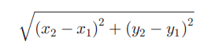

Given the center and a point on the circle, you can use this formula to find the radius of the circle. Write a program that prompts the user to enter the center and a point on the circle. The program should then output the circle’s radius, diameter, circumference, and area. Your program must have at least the following functions:

* 1. **distance**: This function takes as its parameters four numbers that represent two points in the plane and returns the distance between them.
  2. **radius**: This function takes as its parameters four numbers that represent the center and a point on the circle, calls the function distance to find the radius of the circle, and returns the circle’s radius.
  3. **circumference**: This function takes as its parameter a number that represents the radius of the circle and returns the circle’s circumference. (If r is the radius, the circumference is 2πr.)
  4. **area**: This function takes as its parameter a number that represents the radius of the circle and returns the circle’s area. (If r is the radius, the area is πr2.)

Assume that π = 3.1416.

## TASK – 05:

During the tax season, every Friday, J&J accounting firm provides assistance

to people who prepare their own tax returns. Their charges are as follows.

1. If a person has low income (<= 25,000) and the consulting time is less than or equal to 30 minutes, there are no charges; otherwise, the service charges are 40% of the regular hourly rate for the time over 30 minutes.
2. For others, if the consulting time is less than or equal to 20 minutes, there are no service charges; otherwise, service charges are 70% of the regular hourly rate for the time over 20 minutes.

(For example, suppose that a person has low income and spent 1 hour and 15 minutes, and the hourly rate is $70.00. Then the billing amount is 70.00 x 0.40 x (45 / 60) = $21.00.)

Write a program that prompts the user to enter the hourly rate, the total consulting time, and whether the person has low income. The program should output the billing amount. Your program must contain a function that takes as input the hourly rate, the total consulting time, and a value indicating whether the person has low income. The function should return the billing amount. Your program may prompt the user to enter the consulting time in minutes.